20
iOS EW202W SDK
V1.0
Author: CUI XIAODONG
2020/05/26

Modification Record
Date | Item | Person
2020-05-26 | File created | CUI XIAODONG
2020-06-18 | Document check | Shawn
2022-09-15 | Update document | Liu xiaosan
2022-10-28 | Add check WiFi method,firmware>1.37 | Liu Xiaosan
2023-02-14 | Add sync time by hand | Liu Xiaosan

内部文档 严禁外传

Contents
Modification Record １
Contents ２
I. APP iOS SDK ５
Functions and Objectives ５
II. Development Preparation ５
1 .framework ５
2 .Development Environment Settings ５
III. API Description ７
How to call API ７
1. SDK Initialization ７
Interface Description ７
Parameter Description ７
2. Connect BLE ８
Interface Description ８
Parameter Description ８
3. Network Configuration ８
Interface Description ８
Parameter Description ９
4. Authentication Login ９
Interface Description ９
Parameter Description ９
5. Bind device １０
Interface Description １０
Parameter Description １０
6. Unbind device １０
Interface Description １０
Parameter Description １０
7. Sync time by hand １０
Interface Description １１
Parameter Description １１
8. Acquire device info １１
Interface Description １１
Parameter Description １１
9. Initialize the device and restore the factory settings １２
Interface Description １２
Parameter Description １２
10. Work status query １２
Interface Description １２
Parameter Description １２
11. Firmware upgrade １２
Interface Description １３
Parameter Description １３
12. Alarm Configuration(add, modify, delete) １３
Interface Description １３
Parameter Description １３
13. Acquire alarm list １３
Interface Description １３
Parameter Description １４
14. Alarm preview １４
Interface Description １４
Parameter Description １４
15. Light control １４
Interface Description １５
Parameter Description １５
16. Alarm music control １５
Interface Description １５
Parameter Description １５
17. Clock dormancy settings １６
Interface Description １６
Parameter Description １６
18. Acquire clock dormancy １６
Interface Description １６
Parameter Description １６
19. Sleep-aid info configuration １６
Interface Description １７
Parameter Description １７
20. Acquire sleep-aid info １７
Interface Description １７
Parameter Description １７
20.Query the Device WiFi Signal(firmware>1.37) １７
Interface Description １７
Query the wifi signal of equipment １８
Parameters Description １８
21.Query the Device Online Status １８
Interface Description １８
Query the online status of equipment １８
Parameters Description １８
IV. Object Description １８
Notification １８
Method １８
Description １９
SLPBLEScanReturnCodes １９
Description １９
SLPDeviceTypes １９
Description １９
SLPTransforCallback １９
Method １９
Method Description ２０
Parameter Description ２０
SLPDataTransferStatus ２０
Description ２０
SLPPeripheralInfo ２１
Class Description ２１
Field Description ２１
SLPDeviceInfo ２１
Class Description ２１
Field Description ２１
EW202WDeviceInfo ２１
Class Description ２１
Field Description ２１
EW202WWorkState ２２
Class Description ２２
Field Description ２２
SLPLTcpUpgradeInfo ２３
Class Description ２３
Field Description ２３
EW202WAlarmInfo ２３
Class Description ２３
Field Description ２３
EW202WAidInfo ２４
Class Description ２４
Field Description ２４
SLPTimeInfo ２４
Class Description ２４
Field Description ２５
SLPLight ２５
Class Description ２５
Field Description ２５
EW202WClockDormancyBean ２５
Class Description ２５
Field Description ２５
SLPTCPWiFiInfo ２６
Class Description ２６
Field Description ２６
Music List ２６

I. APP iOS SDK

Functions and Objectives
EW202W Android SDK is a software development toolkit launched by Sleepace, aiming to conduct fast development for Internet of Things APP on the Android platform. The SDK encapsulates the communication process between the APP and the hardware, and provides functions such as device configuration, device control, and data query. Using this SDK, users do not need to care about complex communication protocol and the underlying implementation, only need to focus on APP interactions and business levels.

II. Development Preparation

1 .framework

framework | Description
SLPCommon.framework | Common Parts
EW202W.framework | EW202W core
SLPLTCP.framework | SDK core
BLEWifiConfig.framework | BLE configuration
BluetoothManager.framework | BLE configuration related

2 .Development Environment Settings
1: Add library libc++.tbd，Add BluetoothManager.framework,SLPCommon.framework , BLEWifiConfig.framework,SLPCommon.framework,EW202W.framework into the project
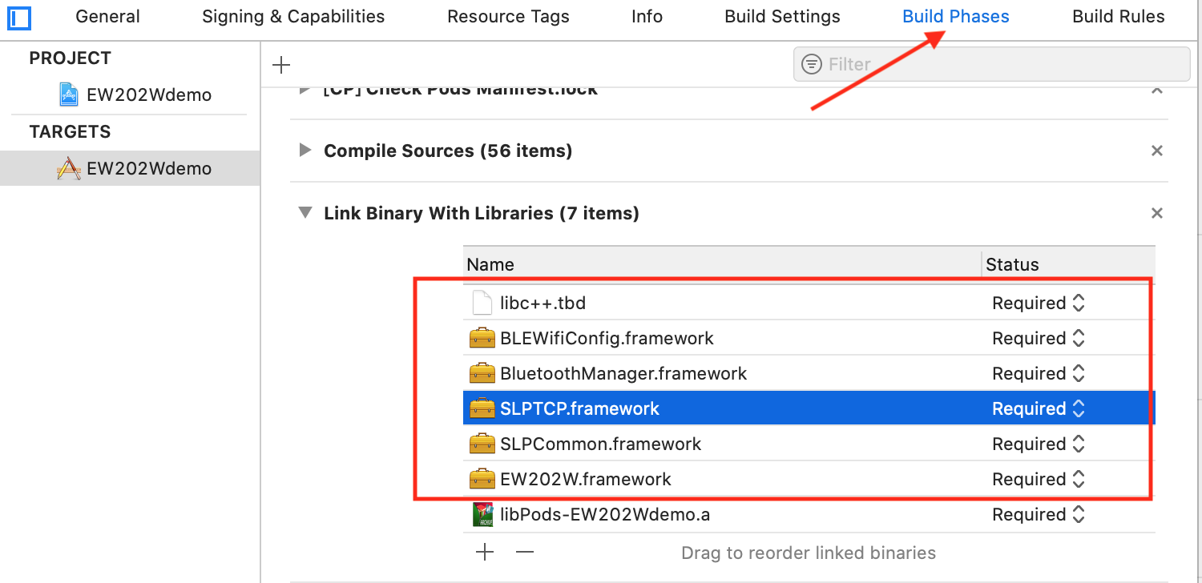

2: Since this SDK uses the third-party library AFNetworking, you need to add AFNetworking to the project. It is recommended to use CocoaPods to manage the third-party library, or you can download and import the project yourself
3: other linker flags ：add library links
-force_load $(SRCROOT)/BLENox2Demo/libs/BluetoothManager.framework/BluetoothManager
-force_load $(SRCROOT)/EW202Wdemo/libs/BLEWifiConfig.framework/BLEWifiConfig
-force_load $(SRCROOT)/EW202Wdemo/libs/SLPTCP.framework/SLPTCP
Notice: $(SRCROOT) is followed by the relative address of the library
If you use CocoaPods to manage AFNetworking, you need to add $(inherited)
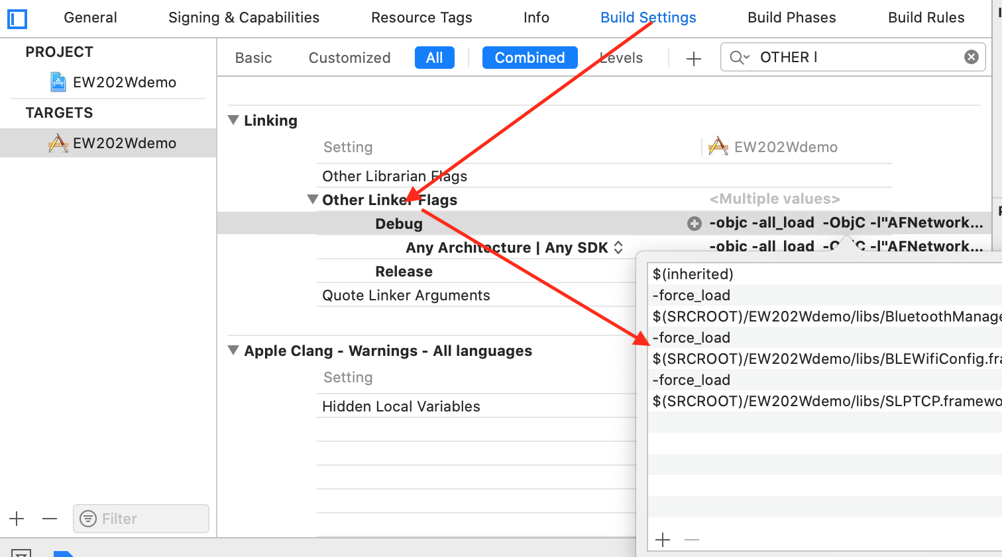

III. API Description

How to call API
You need to call the initialization interface before using the API

- network configuration related
#import <BluetoothManager/BluetoothManager.h>
[SLPBLESharedManager <方法>]

#import <BLEWifiConfig/BLEWifiConfig.h>
[SLPBleWifiConfig <方法>]

- device operation and configuration
#import <EW202W/EW202W.h>
[SLPSharedLTcpManager <方法>]

SDK Initialization
- (void)installSDKWithToken:(NSString *)token ip:(NSString *)ip
channelID:(NSInteger)channelID timeout:(CGFloat)timeoutInterval
completion:(SLPTransforCallback)handle

Interface Description
Used to initialize the SDK, the SDK can be used normally after the call

Parameter Description
Field | Type | Description
token | NSString | User token
ip | NSString | IP address
channelID | NSString | Channel ID
handle | SLPTransforCallback | Callback interface

Connect BLE
- (void)connectAndGetDeviceInfoWithPeripheral:(CBPeripheral *)peripheral
deviceType:(SLPDeviceTypes)deviceType
completion:(void(^)(SLPDataTransferStatus status, id data))completion;

Interface Description
Used to connect the device Bluetooth to acquire device information

Parameter Description
Field | Type | Description
peripheralInfo | SLPPeripheralInfo | See: SLPPeripheralInfo for details
deviceType | SLPDeviceTypes | device type
status | SLPDataTransferStatus | TCP or Bluetooth request return value, see enumeration SLPDataTransferStatus for details
data | id | The callback data is valid when the status is SLPDataTransferReturnStatus_Succeed. The user must convert to a corresponding object with a different interface. For details, please see each Interface Description

Network Configuration
- (void)configPeripheral:(CBPeripheral *)peripheral deviceType:(SLPDeviceTypes)deviceType
serverAddress:(NSString *)address port:(NSInteger)port
wifiName:(NSString *)name
password:(NSString *)password
completion:(void(^)(SLPDataTransferStatus status, id data))completion;

Interface Description
Used for device network configuration

Parameter Description
Field | Type | Description
peripheralInfo | SLPPeripheralInfo | See: SLPPeripheralInfo for details
deviceType | SLPDeviceTypes | Device type
address | NSString | IP Address
port | NSInteger | IP port
name | NSString | WiFi name
password | NSString | WiFi password
status | SLPDataTransferStatus | TCP or Bluetooth request return value, see enumeration SLPDataTransferStatus for details
data | id | The callback data is valid when the status is SLPDataTransferReturnStatus_Succeed. The user must convert to a corresponding object with a different interface. For details, please see each Interface Description

Authentication Login
- (BOOL)loginDeviceID:(NSString *)deviceID completion:(SLPTransforCallback)handle;

Interface Description
-Used to connect to the login device

Parameter Description
Field | Type | Description
deviceID | NSString | Device ID
handle | SLPTransforCallback | Callback interface

Bind device
- (void)bindDevice:(NSString *)deviceID leftRight:(NSInteger)leftRight timeout:(CGFloat)timeoutInterval completion:(SLPTransforCallback)handle;

Interface Description
-used to bind device

Parameter Description
Field | Type | Description
deviceID | NSString | Device ID
leftRight | NSInteger | 0
timeoutInterval | CGFloat | time out
handle | SLPTransforCallback | Callback interface

Unbind device
- (void)unBindDevice:(NSString *)deviceID leftRight:(NSInteger)leftRight timeout:(CGFloat)timeoutInterval completion:(SLPTransforCallback)handle;

Interface Description
-Used to unbind device

Parameter Description
Field | Type | Description
deviceID | NSString | Device ID
leftRight | NSInteger | 0
timeoutInterval | CGFloat | time out
handle | SLPTransforCallback | Callback interface

Sync time by hand
- (void)ew202wSyncTimeByTimestamp:(UInt32)timestamp timeZone:(int32_t)timezone season:(UInt8)season timeMode:(UInt8)timeMode deviceInfo:(NSString *)deviceID
timeout:(CGFloat)timeout callback:(SLPTransforCallback)handle;

Interface Description

Sync device time by hand

Parameter Description
Field | Type | 说明
deviceID | NSString | Device ID
timestamp | UInt32 | Timestamp ，unit:second
timezone | int32 | Timezone，ex：（UTC/GMT+08:00） 28800
season | UInt8 | Season, 0:None,1:summer time,2:Standard Time
timeMode | UInt8 | Time mode，12： 12-hour system，24：24-hour system
timeout | CGFloat | Timeout unit:second
handle | SLPTransforCallback | Callback interface

Acquire device info
- (void)ew202wGetDeviceInfo:(NSString *)deviceName deviceType:(SLPDeviceTypes)deviceType timeout:(CGFloat)timeout callback:(SLPTransforCallback)handle;

Interface Description
to acquire device info

Parameter Description
Field | Type | Description
deviceName | NSString | Device name
deviceType | SLPDeviceTypes | Device type
timeout | CGFloat | timeout unit:second
handle | SLPTransforCallback | Callback interface, return object successfully data= EW202WDeviceInfo

Initialize the device and restore the factory settings
- (void)ew202wDeviceInitWithDeviceInfo:(NSString *)deviceName timeout:(CGFloat)timeout callback:(SLPTransforCallback)handle;

Interface Description
to restore to the factory settings

Parameter Description
Field | Type | Description
timeout | CGFloat | timeout unit:second
deviceName | NSString | device name
handle | SLPTransforCallback | Callback interface

Work status query
- (void)ew202wGetWorkStatusWithDeviceInfo:(NSString *)deviceName timeout:(CGFloat)timeout callback:(SLPTransforCallback)handle;

Interface Description
It is used to acquire the working status of the device. When the status of the device changes, the user can acquire the real-time status by monitoring kNotificationNameEW202WWorkModeChange.

Parameter Description
Field | Type | Description
timeout | CGFloat | timeout unit:second
deviceName | NSString | device name
handle | SLPTransforCallback | Callback interface,return object successfully data= EW202WWorkState

Firmware upgrade
- (void)ew202wPublicUpdateOperationWithDeviceID:(NSString *)deviceID deviceType:(SLPDeviceTypes)deviceType firmwareType:(UInt8)firmwareType firmwareVersion:(UInt16)version timeout:(CGFloat)timeout callback:(SLPTransforCallback)handle;

Interface Description
to operate firmware upgrade

Parameter Description
Field | Type | Description
deviceID | String | Device ID
version | UInt16 | Firmware version
deviceType | SLPDeviceTypes | Device type
firmwareType | int | Firmware type
handle | SLPTransforCallback | Callback interface

Alarm Configuration(add, modify, delete)
- (void)ew202wAlarmConfig:(EW202WAlarmInfo *)alarmInfo deviceInfo:(NSString *)deviceName timeout:(CGFloat)timeout callback:(SLPTransforCallback)handle;

Interface Description
to add, modify, delete alarm

Parameter Description
Field | Type | Description
alarmInfo | EW202WAlarmInfo | alarm info
deviceName | NSString | device name
timeout | CGFloat | timeout unit:second
handle | SLPTransforCallback | Callback interface

Acquire alarm list
- (void)ew202wGetAlarmListWithDeviceInfo:(NSString *)deviceName timeout:(CGFloat)timeout completion:(SLPTransforCallback)handle;

Interface Description
to acquire alarm list

Parameter Description
Field | Type | Description
timeout | CGFloat | timeout unit:second
deviceName | NSString | device name
handle | SLPTransforCallback | Callback interface, successfully returned object data is an array of EW202WAlarmInfo

Alarm preview
- (void)ew202wAlarmRreviewOperationVolume:(UInt8)volume brightness:(UInt8)brightness operation:(UInt8)operation musicID:(UInt16)musicID deviceInfo:(NSString *)deviceName timeout:(CGFloat)timeout callback:(SLPTransforCallback)handle;

Interface Description
to preview alarm and end preview

Parameter Description
Field | Type | Description
volume | UInt8 | Volume [0,16] 0:mute
brightness | UInt8 | Brightness[0,100] 0:no brightness
operation | UInt8 | preview operation 0:off 1:on
musicID | UInt16 | Music ID
timeout | CGFloat | timeout unit:second
deviceName | NSString | device name
handle | SLPTransforCallback | Callback interface

Light control
- (void)ew202wLightControlOperation:(UInt8)operation brightness:(UInt8)brightness lightMode:(UInt8)lightMode light:(SLPLight *)light deviceInfo:(NSString *)deviceName timeout:(CGFloat)timeout callback:(SLPTransforCallback)handle;

Interface Description
to control light, turn on light and turn off light

Color code: 0:warm white 1:cold white 2:red 3:orange 4:warm yellow 5:green 6:cyan-blue 7:blue 8:purple 9:light-cycling 0xff: color (custom color, need to assign RGBW), if it is 0-9, don't pay attention to the value of RGBW

Parameter Description
Field | Type | Description
operation | UInt8 | operation code 0:turn off light 1:turn on light 2:adjust brightness
brightness | UInt8 | Brightness[0,100] 0:no brightness
lightMode | UInt8 | color code
light | SLPLight | See: SLPlight for details
deviceName | NSString | device name
handle | SLPTransforCallback | Callback interface

Alarm music control
- (void)ew202wAlarmMusicOperation:(UInt8)operation musicID:(UInt16)musicID volume:(UInt8)volume deviceInfo:(NSString *)deviceName timeout:(CGFloat)timeout callback:(SLPTransforCallback)handle;

Interface Description
to turn on music, turn off music, set volume

Parameter Description
Field | Type | Description
operation | UInt8 | operation code 0:stop 1:play 2:adjust volume
musicID | UInt16 | Music ID
volume | UInt8 | Volume [0,16] 0:mute
timeout | CGFloat | timeout unit:second
deviceName | NSString | device name
handle | SLPTransforCallback | Callback interface

Clock dormancy settings
- (void)ew202wConfigClockDormancy:(EW202WClockDormancyBean *)clockDormancyBean deviceInfo:(NSString *)deviceName timeout:(CGFloat)timeout callback:(SLPTransforCallback)handle;

Interface Description
for clock dormancy settings

Parameter Description
Field | Type | Description
clockDormancyBean | EW202WClockDormancyBean | See: EW202WClockDormancyBean for details
deviceName | NSString | device name
handle | SLPTransforCallback | Callback interface

Acquire clock dormancy
- (void)ew202wGetClockDormancyWithDeviceInfo:(NSString *)deviceName timeout:(CGFloat)timeout callback:(SLPTransforCallback)handle;

Interface Description
to acquire clock dormancy

Parameter Description
Field | Type | Description
timeout | CGFloat | timeout unit:second
deviceName | NSString | device name
handle | SLPTransforCallback | For callback result please see: EW202WClockDormancyBean for details

Sleep-aid info configuration
- (void)ew202wConfigAidInfo:(EW202WAidInfo *)aidInfo deviceInfo:(NSString *)deviceName timeout:(CGFloat)timeout callback:(SLPTransforCallback)handle;

Interface Description
to configure sleep-aid info

Parameter Description
Field | Type | Description
aidInfo | EW202WAidInfo | See: EW202WAidInfo for details
timeout | CGFloat | timeout unit:second
deviceName | NSString | device name
handle | SLPTransforCallback | Callback interface

Acquire sleep-aid info
- (void)ew202wGetAidInfoWithDeviceInfo:(NSString *)deviceName timeOut:(CGFloat)timeout callback:(SLPTransforCallback)handle;

Interface Description
to acquire sleep-aid info

Parameter Description
Field | Type | Description
timeout | CGFloat | timeout unit:second
deviceName | NSString | device name
handle | SLPTransforCallback | Callback interface, see: EW202WAidInfo for details

20.Query the Device WiFi Signal(firmware>1.37)
- (void)publicGetWiFiSignalWithDeviceID:(NSString *)deviceID deviceType:(SLPDeviceTypes)deviceType timeout:(CGFloat)timeout callback:(SLPTransforCallback)handle;

Interface Description

Query the wifi signal of equipment

Parameters Description
Field | Type | Description
deviceID | NSString | Device ID
deviceType | Int | Device type
timeout | Float | Time-out period
handle | SLPTransforCallback | Call back ,back SLPTCPWiFiInfo object

21.Query the Device Online Status
- (void)publicGetOnlineStatusWithDeviceID:(NSString *)deviceID deviceType:(SLPDeviceTypes)deviceType timeout:(CGFloat)timeout callback:(SLPTransforCallback)handle;

Interface Description

Query the online status of equipment

Parameters Description
Field | Type | Description
deviceID | NSString | Device ID
deviceType | Int | Device type
timeout | Float | Time-out period
handle | SLPTransforCallback | Call back

IV. Object Description

Notification

Method
object: Handle of TCP device SLPLTcp*lTcp
userInfo: @{key: Content }

Description
Key | Content | Description
kNotificationNameEW202WWorkModeChanged | EW202WWorkState | device status has changed
kNotificationNameNoxUpdateRateChanged | SLPLTcpUpgradeInfo | Upgrade progress
kNotificationNameLTCPDisconnected |  | Long connection disconnected
kNotificationNameLTCPConnected |  | Long connection connected
kNotificationNameRequestDeviceOnlineStatusChanged |  | Device online status changed
kNotificationNameRequestDeviceWiFiSignalChanged |  | WiFi signal changed

SLPBLEScanReturnCodes

Description
Field | Value | Description
SLPBLEScanReturnCode_Normal | 0 | Successfully scanned a BLE device
SLPBLEScanReturnCode_Disable | 1 | BLE disabled
SLPBLEScanReturnCode_TimeOut | 2 | Scan timeout

SLPDeviceTypes

Description
Field | Value | Description
SLPDeviceType_EW202W | 0x35 | EW202WDevice type

SLPTransforCallback

Method
Callback on Bluetooth or TCP request

Method Description
typedef void(^SLPTransforCallback)(SLPDataTransferStatus status,id data);

Parameter Description
Field | Type | Description
status | SLPDataTransferStatus | TCP or Bluetooth request return value, see enumeration SLPDataTransferStatus for details
data | id | The callback data is valid when the status is SLPDataTransferReturnStatus_Succeed. The user must convert to a corresponding object with a different interface. For details, please see each Interface Description

SLPDataTransferStatus

Description
Field | Value | Description
SLPDataTransferStatus_Succeed | 0 | Succeed
SLPDataTransferStatus_ConnectionDisconnected | 1 | Disconnected
SLPDataTransferStatus_TimeOut | 2 | Timeout
SLPDataTransferStatus_Failed | 3 | Failed
SLPDataTransferStatus_ConnectionDisabled | 4 | Connection disabled or disconnected
SLPDataTransferStatus_ParameterError | 5 | Parameter Error

SLPPeripheralInfo

Class Description
Bluetooth scan return class

Field Description
Field | Type | Description
peripheral | CBPeripheral | Bluetooth handle
name | String | device name

SLPDeviceInfo

Class Description
The device connection interface will return

Field Description
Field | Type | Description
deviceID | String | Device ID
version | String | Device’s Firmware version

EW202WDeviceInfo

Class Description
Acquire device information interface will return

Field Description
Field | Type | Description
deviceID | String | Device ID
firmwareVersion | String | Device’s Firmware version

EW202WWorkState

Class Description
The working status of the device. Users can take the initiative to acquire, the device can also take the initiative to submit

Field Description
Field | Type | Description
mode | UInt8 | Work mode 0:normal 1: configuration
lightStatus | UInt8 | Light status 0:off 1:lighting 2:sleep-aid light 3:Custom color light 4:alarm light
brightness | UInt8 | Brightness
lightMode | UInt8 | Light mode 0:warm white 1cold white 2:red 3:orange 4:warm yellow 5:green 6:cyan-blue 7:blue 8:purple 9:light-cycling
light | SLPLight | Light  Fixed light-cycling This item is nil
alarmStatus | UInt8 | Alarm status 0x00:not running 0x01:running 0x02:snoozing 0x03:previewing
timeMode | UInt8 | Time format 0:12hr format 1:24hr format
pincode | UInt8 | BLE PIN switch 0:off 1:on
systemBluetooth | UInt8 | BLE switch 0:off 1:on
syncServerFlag | UInt8 | Sync server switch 0:off 1:on
asssitStaus | UInt8 | Sleep-aid status 0:stop 1:running
asssitLightStaus | UInt8 | Sleep-aid light status 0:off 1:on
assistMusicStatus | UInt8 | Sleep-aid music status 0:off 1:on
assistMusicID | UInt16 | Music ID
assistTimeRemained | UInt8 | Remained sleep-aid time
channelNum | UInt32 | Channel number 0:Local report

SLPLTcpUpgradeInfo

Class Description
After calling the firmware upgrade interface, the device will automatically report the upgrade status, and the monitoring notification kNotificationNameNoxUpdateRateChanged can be acquired.

Field Description
Field | Type | Description
rate | NSInteger | Upgrade progress (progress 0-100%)

EW202WAlarmInfo

Class Description
Alarm info, add (modify) the parameter type of the alarm interface

Field Description
Field | Type | Description
alarmID | UInt64 | Alarm ID, Unique ID, generally provided by server
isOpen | BOOL | Alarm Switch
hour | UInt8 | Hour
minute | UInt8 | Minute
flag | UInt8 | repeat  Monday-Sunday switch (0-6 position) 0: off, 1: on  All 0 means single alarm, set timestamp as expiration standard
snoozeTime | UInt8 | Snooze Time
snoozeLength | UInt8 | Snooze Length
volume | UInt8 | Volume 0-16
brightness | UInt8 | Brightness 0-100
musicID | UInt16 | Music ID
timestamp | UInt32 | Timestamp, set / modify the standard timestamp when alarm is used (for single alarm)
enable | UInt8 | Whether it is valid, 0 means the alarm has been deleted, 1 means the alarm is valid, use this interface to delete the alarm, set this field to 0

EW202WAidInfo

Class Description
Save the parameter type of the sleep-aid info interface

Field Description
Field | Type | Description
musicFlag | UInt8 | Music On/Off
musicID | UInt16 | Music ID
volume | UInt8 | Volume Volume(0-16) 0:Mute
musicMode | UInt8 | Loop mode 0:List play 1:Single loop
lightFlag | UInt8 | Light switch
brightness | UInt8 | Brightness (0-100)
r | UInt8 | Light Color r Component 0-255
g | UInt8 | Light Color g Component 0-255
b | UInt8 | Light Color b Component 0-255
w | UInt8 | Light Color W Component 0-255 (current W component is 0)
smartStopFlag | UInt8 | Whether to turn on smart sleep-aid
aidStopDuration | UInt16 | Sleep-aid stop time, unit: minutes

SLPTimeInfo

Class Description
Timezone, parameter type of time calibration interface

Field Description
Field | Type | Description
timestamp | UInt32 | Timestamp
timezone | int32_t | Timezone
season | UInt8 | Special Season 0: None, 1: Daylight Saving Time, 2: Winter Time
offset | int32_t | Special seasonal offset  Offset information, unit: second
timeMode | UInt8 | 12:12hr format 24:24hr format

SLPLight

Class Description
Light Information

Field Description
Field | Type | Description
r | UInt8 | Light Color r Component 0-255
g | UInt8_t | Light Color g Component 0-255
b | UInt8 | Light Color b Component 0-255
w | UInt8 | Light Color w Component 0-255

EW202WClockDormancyBean

Class Description
Clock dormancy structure

Field Description
Field | Type | Description
flag | int | Clock dormancy switch 0: off 1: on
startHour | int | Clock dormancy start time: hour
startMin | int | Clock dormancy start time: minute
endHour | int | Clock dormancy end time: hour
endMin | int | Clock dormancy end time: minute

SLPTCPWiFiInfo

Class Description
Query device wifi

Field Description
Field | Type | Description
deviceID | String | Device ID
deviceType | int | Device type
signalStrength | Int | WiFi signal 0-4

Music List
alarm music
ID | name
31143 | Chirping Birds
31144 | Chirping Birds
31145 | Romantic Morning
31146 | Di Di Di
31147 | Good Morning, World
31148 | Little Music Box

aid sleep music
ID | name
31131 | Run To You
31132 | Silver Moon
31133 | Here I Am
31134 | Our Journey
31135 | Joyous World
31136 | Sweet Baby
31137 | Celtic Lullaby
31138 | Sweet Lullaby
31139 | Cozy Fire
31140 | Waves of the Ocean
31141 | Rain
31142 | Little Music Box

